This guide will take you through the installation and setup of the Turnitin app on your iPad and how to use it for marking student assignments offline.
Before using the Turnitin app, please note that your personal iPad must comply with the IT Services terms and conditions, which are designed to protect sensitive data in the case of accidental loss or theft of your mobile device.

App Installation
- Download and install the Turnitin Feedback Studio App from the App Store https://apps.apple.com/gb/app/turnitin-feedback-studio/id657602524
Note: please do not try to login to the app at this point. Continue to follow the instructions.
- Once installed, check the app settings to ensure it is set to Feedback Studio UK
- Go to Settings on your iPad
- Scroll down the menu to find Turnitin in the list of apps and select it.
- Make sure Feedback Studio UK is ticked. If it is not, tap it to select it.
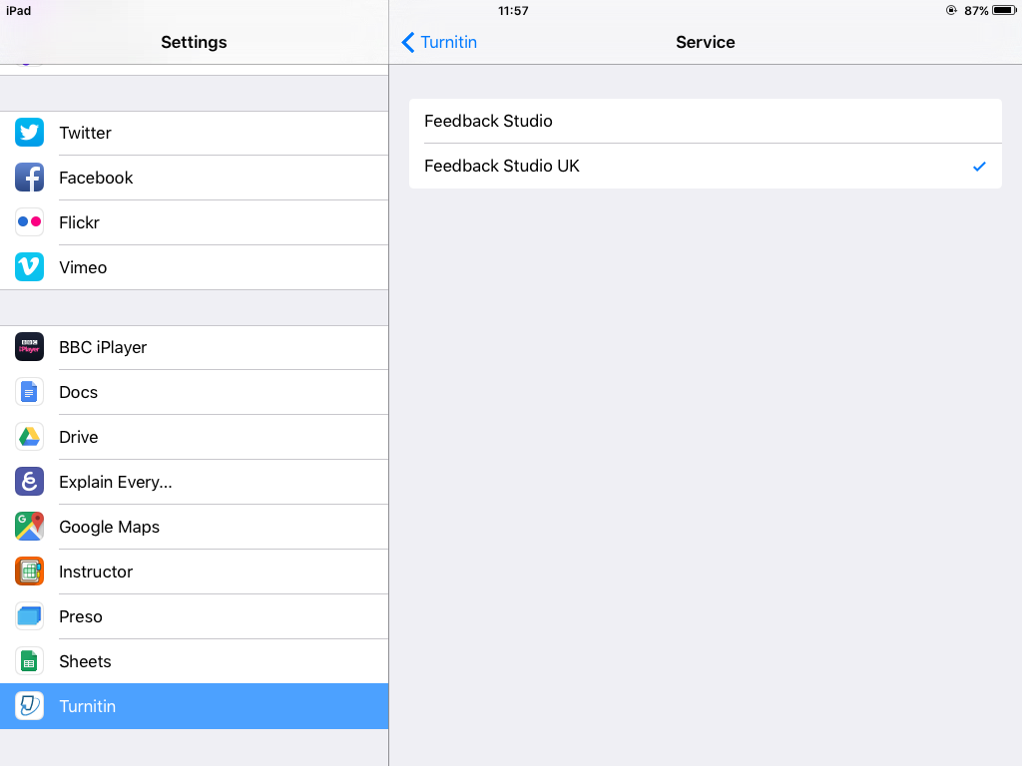

Setting up your course unit on the Turnitin App
In order to access your course unit from the iPad, you need to send yourself an activation email. To do this, you need to:
- Login to Blackboard via online.manchester.ac.uk
- Enter the Blackboard course unit where you want to do marking.
- Go to Course Tools -> Turnitin Assigments and select the assignment you want to mark.
- Open any student submission (as if marking) and locate the Info icon (see right).
- Add in your email and click Email me.
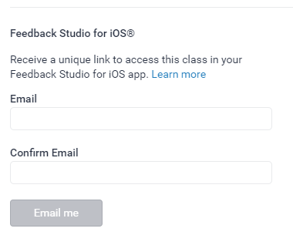
Important: if you have your work email set up on a personal iPad (or any other personal mobile device), please ensure it follows the IT Services terms and conditions to protect sensitive data in case of accidental loss or theft. Information on setting up your email on an iPad can be found in this Helpdesk article.
- Open the email on your iPad and click Add class. The Turnitin app on your iPad should automatically open.
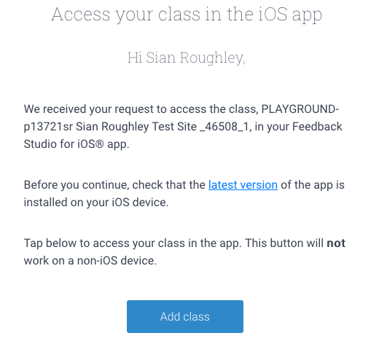
Note: this email must be opened on your iPad.

Accessing Assignments in the Turnitin for iPad App
Once you have added your course via the email, you will have access to your course unit and all assignments within it.
- Click on the course name from the list.
- Select the relevant Turnitin assignment.

Downloading the Turnitin assignments
Before you can begin to mark offline, you must first download the assignments in the app.
- Once in your assignment inbox, press the Info icon in the top right of the screen to display the Assignment Info. Ensure that Download All is switched on. This will download all the submission for this assignment. 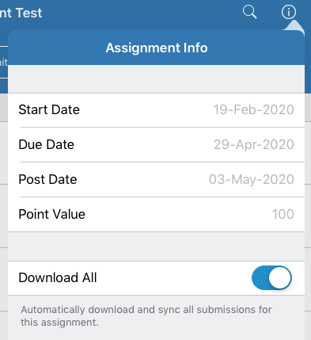
- Once the assignments have downloaded, you will be able to go offline and click on any of the student submissions to begin marking.
Note: when in a student’s submission, you can swipe to the left to move onto the next submission in the list.

Marking while offline in the Turnitin iPad App
Now that you’re in the Feedback Studio you will be able to add any comments or feedback to the student’s submission. There are several different ways you can do this.
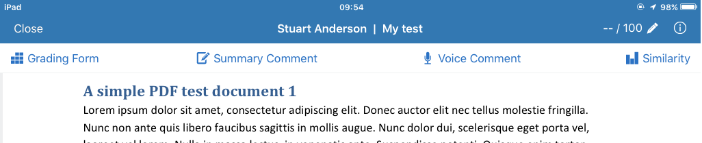

Grading Form
The Grading Form will open any rubrics you have attached to the assignment.
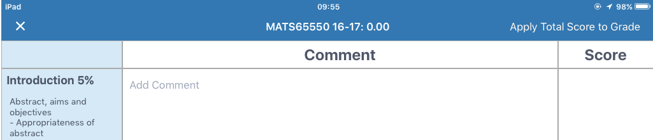

Summary Comment
The Summary Comment button allows you to add any overall feedback to the student’s work.
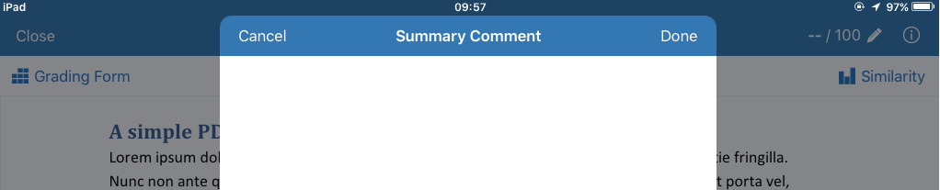

Voice Comment
The Voice Comment button will open the voice recorder. It can record up to 3 minutes of feedback.
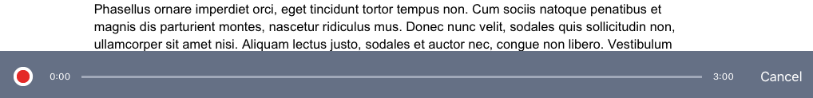

Adding inline marking
There is also an option to add inline marking onto the student’s work. This can be done by tapping anywhere on the student’s submission and selecting to add either a comment or to type directly onto the students work.
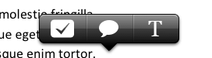
If you want to remove either the comment or the text that you have added, this can be done by clicking back on them and pressing the delete button or icon.
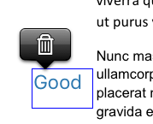
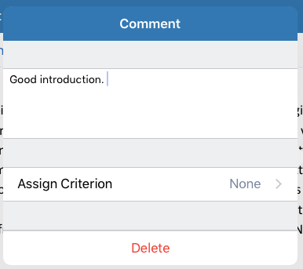

Viewing the Similarity Report
You may also want to view the Similarity Report while viewing the student’s submission. You can do this by clicking Similarity.
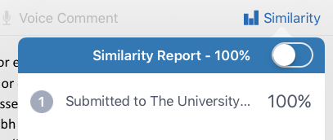
For more information on interpreting Similarity Reports, please see the Turnitin website.

Adding a grade to the assignment
Once you have finished adding your feedback, you may also need to give the student a grade. This can be done by pressing the grade icon in the top-right of the screen and entering the grade.
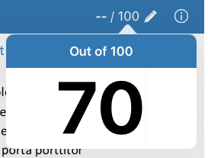

Syncing your feedback
When you have finished all of your marking you can sync this with the Feedback Studio online. As soon as your iPad is re-connected to WiFi it will immediately sync. If you have remained connected to WiFi whilst marking, the app will sync automatically every 5 minutes.
If for any reason your marking/feedback does not seem to have synced, you can go back to the Classes page in the iPad app and press the menu icon in the top left and press Sync Now.
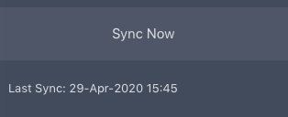
All your marks and feedback should now be accessible via Blackboard.

Further information
For more information on using the Turnitin iPad app, you can find a full list of resources here on the Turnitin website.

